Answers of systems
Bank System
Use case diagram
Actors:
• Customer (Bank Client) — primary
• Bank System Administrator — secondary
• System — secondary
Use Cases:
- Login Bank Account
- Request Withdraw
- Check Balance
Relationships (include/extend):
- Request Withdraw includes Login Bank Account
- Check Balance includes Login Bank Account
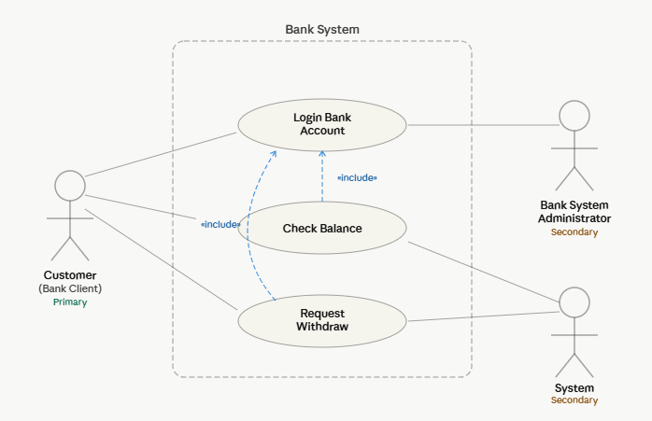

Hotel Reservation & Management System
• Use Case Diagram — Hotel Reservation System
• Activity Diagram — Booking a Room Process
1-Use case diagram
Actors:
Primary Guest
SecondaryAdmin
External Payment System
Use Cases:
1-View Available Rooms
2-Filter Rooms by Type
3-Reserve Room
4-Enter Personal Details
5-Make Payment
6-Confirm Booking
7-Manage Rooms
8-View Reservations
9-Update Room Status
Relationships (include/extend):
«Include» Reserve Room → Enter Personal Details
«Include» Reserve Room → Make Payment
«Include» Make Payment → Confirm Booking

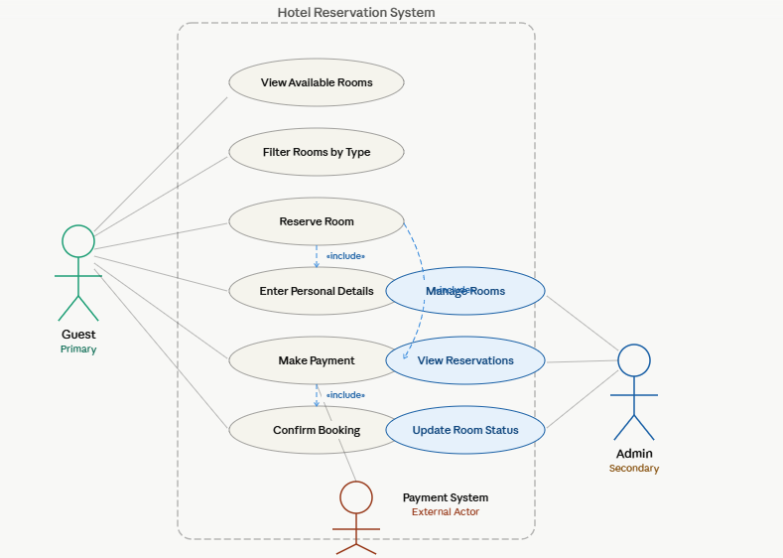
2- Activity Diagram
Start → Search → Decision 1 (Room Available?) → Select → Details → Payment → Decision 2 (Payment OK?) → Confirm → Parallel: Save + Send Confirmation → End
If found Parallel action make Fork
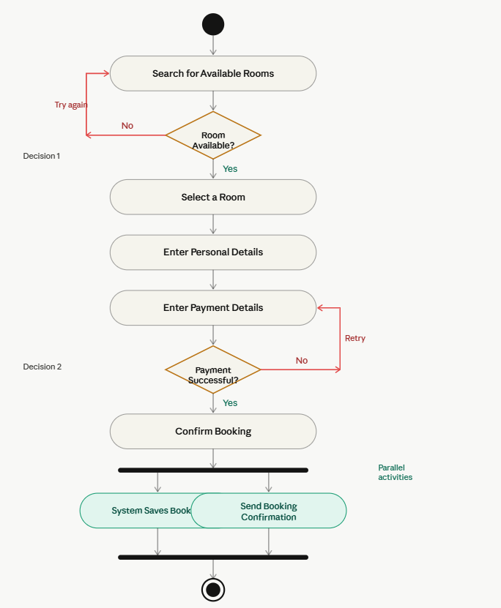

Hospital Appointment & Patient Management System
• Use Case Diagram — Hospital Appointment System
• Activity Diagram — Patient Appointment Booking Process
1-Use case diagram
Actors:
Primary Patient
Secondary Hospital Admin
ExternalSystem (Notification)
Use Cases:
- Login Patient Account
- Search Available Appointments
- Send Appointment Request
- Submit Appointment Request
- View Appointment Confirmation
- Cancel / Reschedule Appointment
- Upload Medical Documents

Relationships
«Include “Search Available Appointments → Login Patient Account
«Include “Submit Appointment Request → Send Appointment Request
«Include “Submit Appointment Request → Upload Medical Documents
«Extend “Cancel / Reschedule Appointment extends Submit Appointment Request
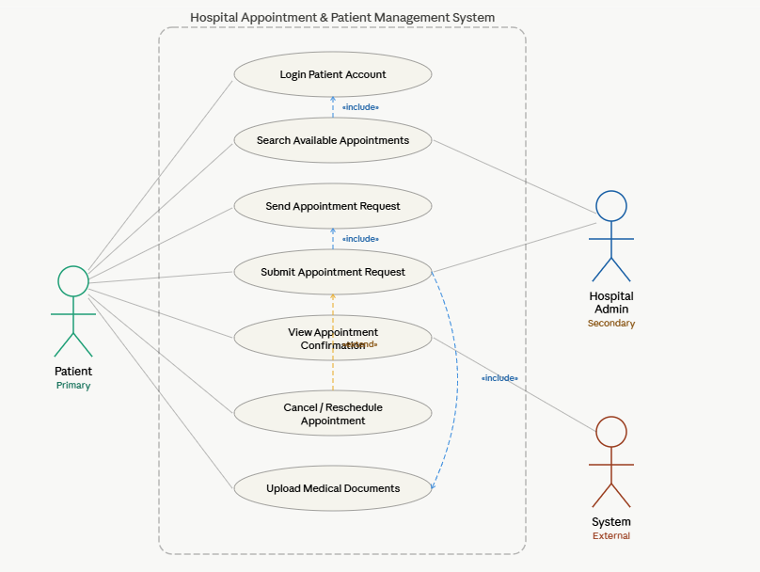

2-Activity diagram
Patient Actions (Swimlane)
- Opens web browser
- Navigates to hospital website
- Clicks "Book Appointment"
- Selects appointment slot
- Enters personal details
- Confirms booking

System Actions (Swimlane)
- Loads booking interface
- Shows available slots
- Validates patient info
- Saves appointment
- Sends confirmation

Decision Points & Parallel Activities
Decision 1Website Loaded Successfully?
Decision 2Time Slot Available?
Decision 3 Patient Info Correct?
Parallel Save Appointment + Send Confirmation Email
